TITLE (TNR, 16, CENTER, UPPERCASE)

Author (TNR, 12, Bold, Centre, Capitalize Each Word) ¹

¹Author details (TNR, 10,)

__________________________________________________________________________________________

Abstract :( TNR, 12, italic, single spacing).

Keywords: (TNR, 12, single spacing)
___________________________________________________________________________

Introduction (TNR, 12, bold, align left)

Tourism in rural areas plays an important role …… (TNR, 12, single spacing, justify)

Literature review (TNR, 12, bold, align left)

Definition and concepts of rural tourism (TNR, 12, bold, italic, align left)

In particular, Irshad (2010)’s review of Page and Getz (1997)……. (TNR, 12, single spacing, justify)
Rural Tourism (TNR, 12, bold, italic, align left)
As mention by Irshad (2010)’s ……… (TNR, 12, single spacing, justify).
Table 1: Example (TNR, 10, single spacing, bold, centre)
Example | Example | Example
Example | Example | Example
Example | Example | Example

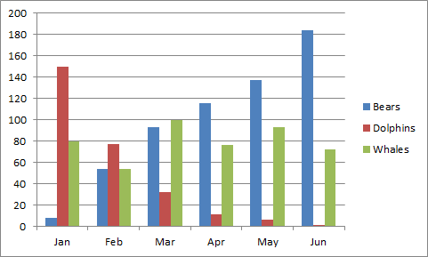
Figure 1: Example (TNR, 10, single spacing, bold, centre)
Criteria for Best Paper Award:

* minimum references are 15
* minimum 3pages and maximum 9pages
* empirical paper
* submit paper 2 weeks before conference

References (APA Sixth Edition)
The minimum are 15 references.

